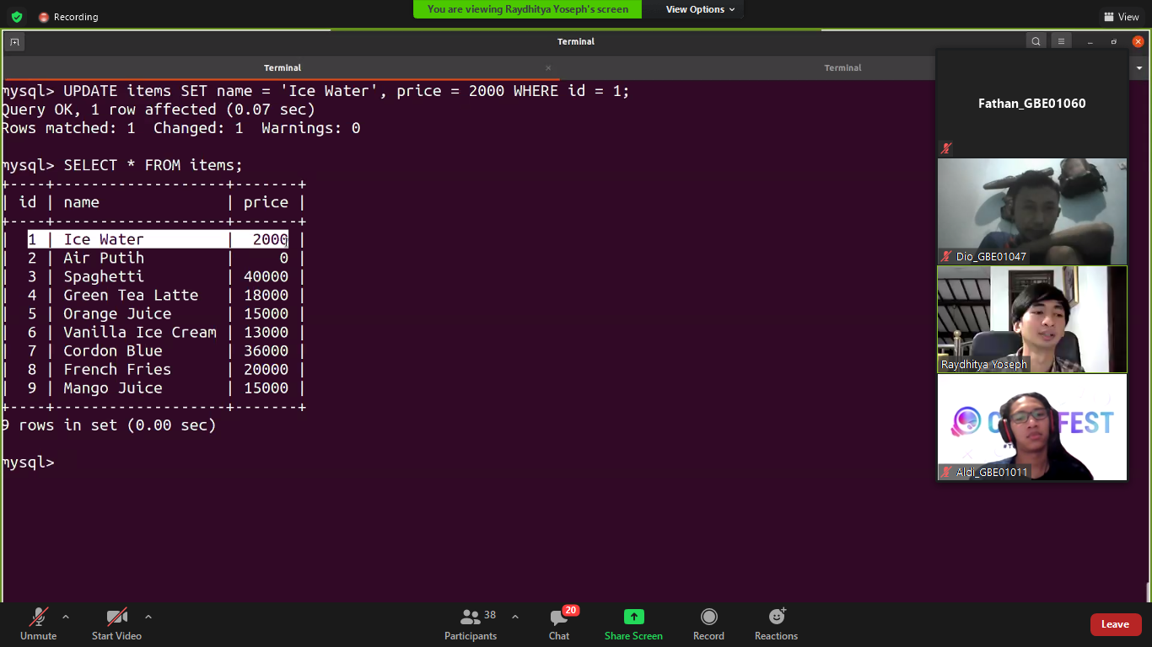

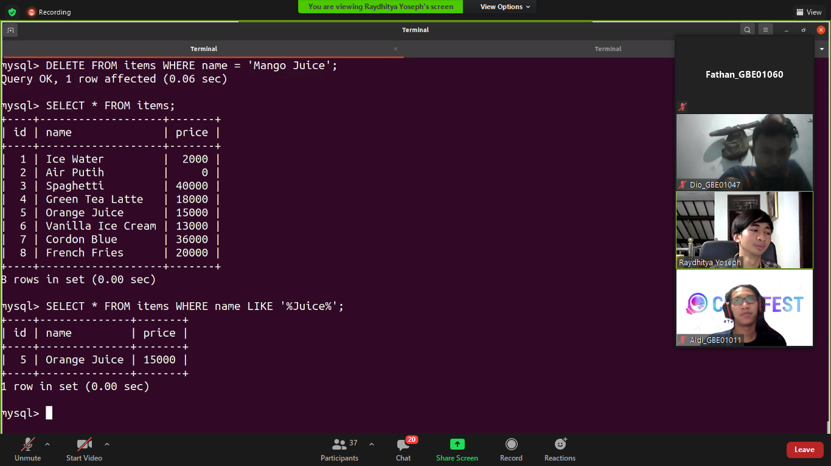

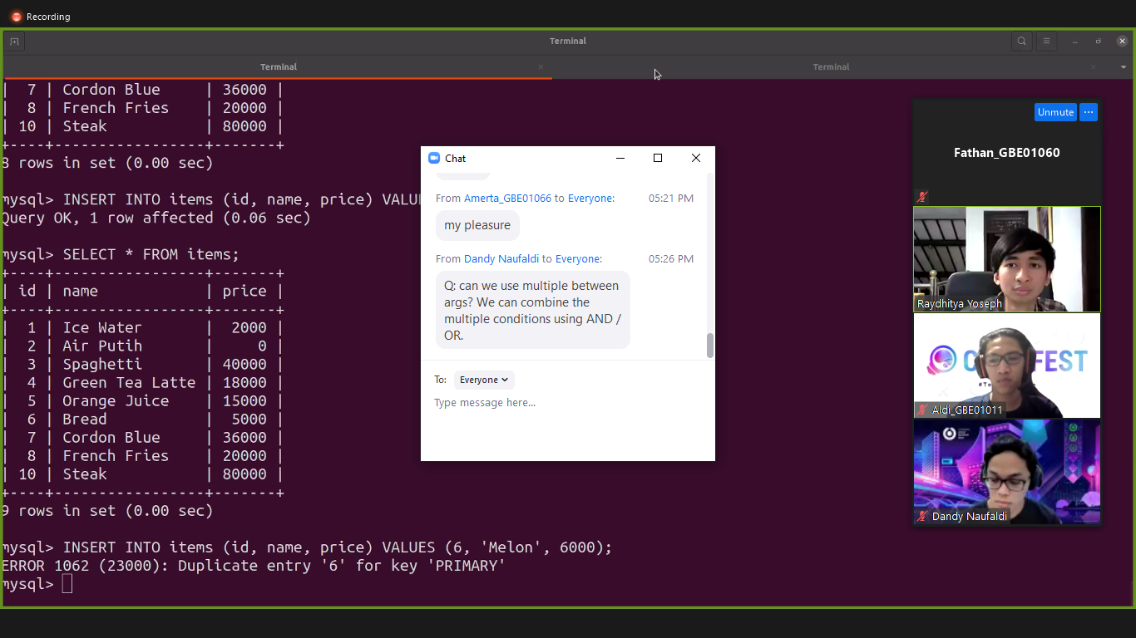

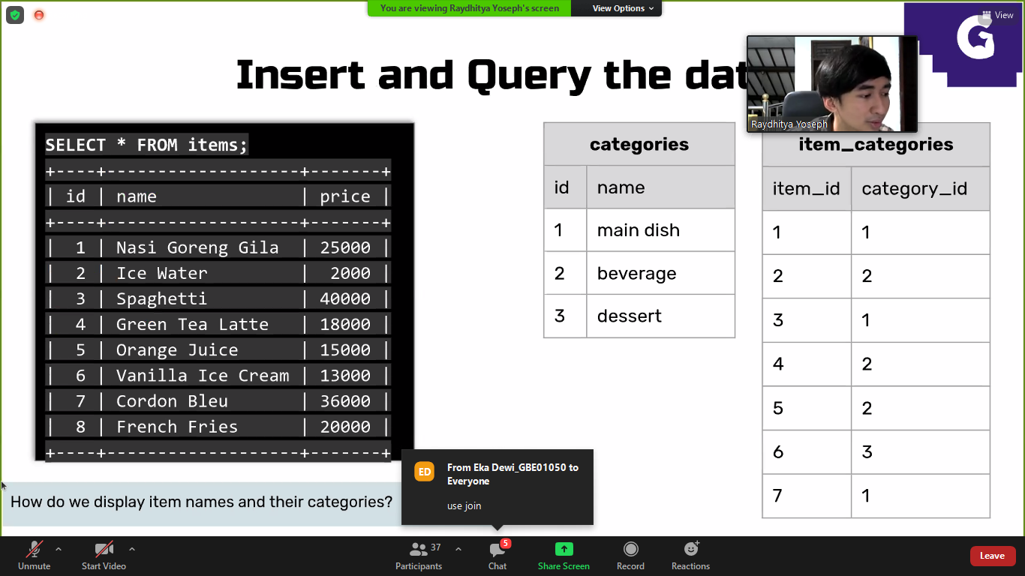

ALTER TABLE items  
ADD CONSTRAINT FK_PersonOrder  
FOREIGN KEY (PersonID) REFERENCES Persons(PersonID);

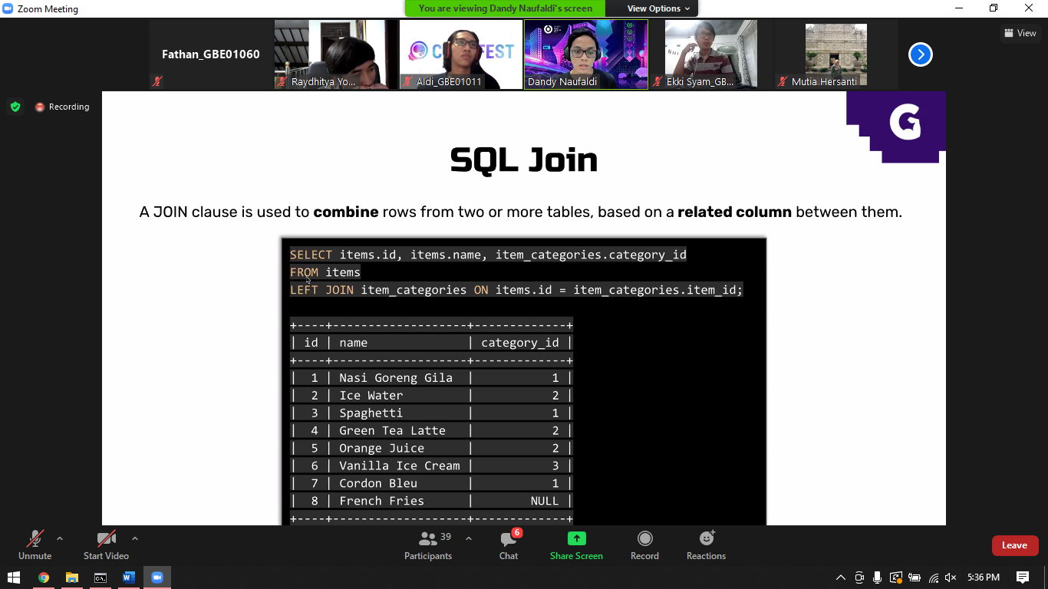

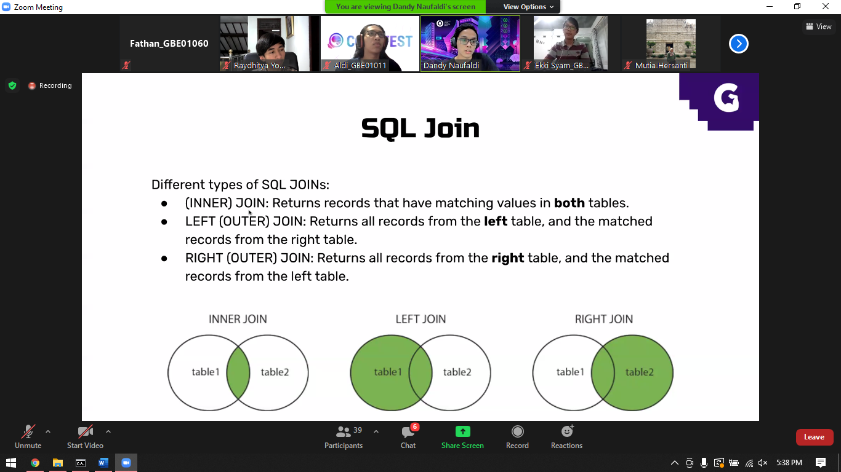

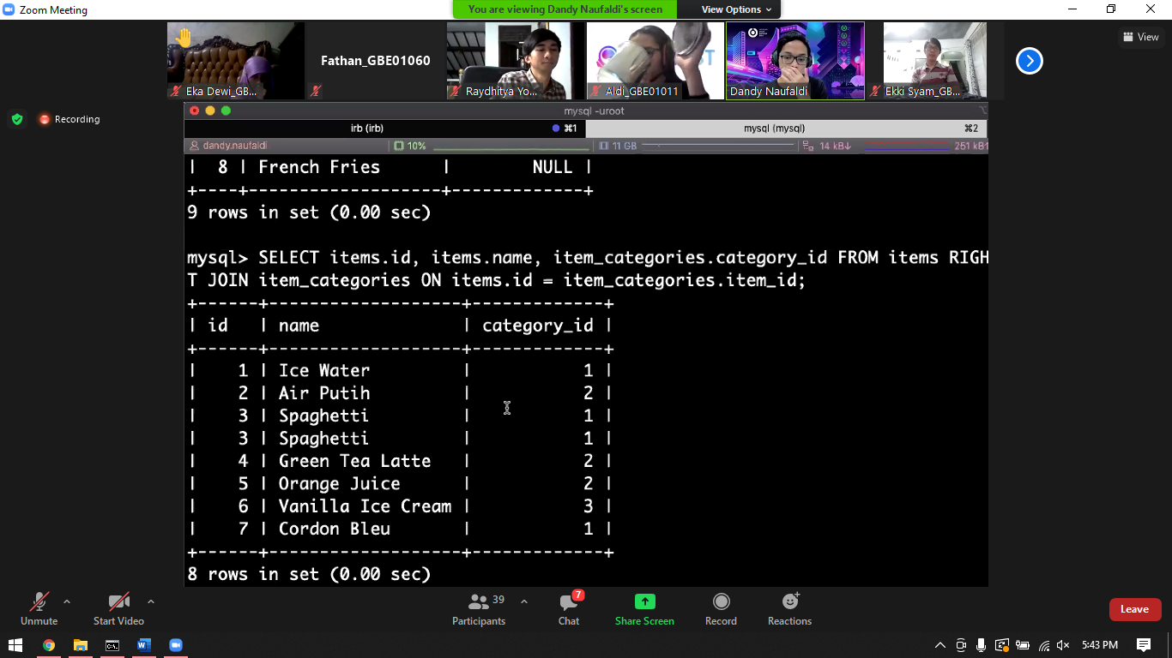

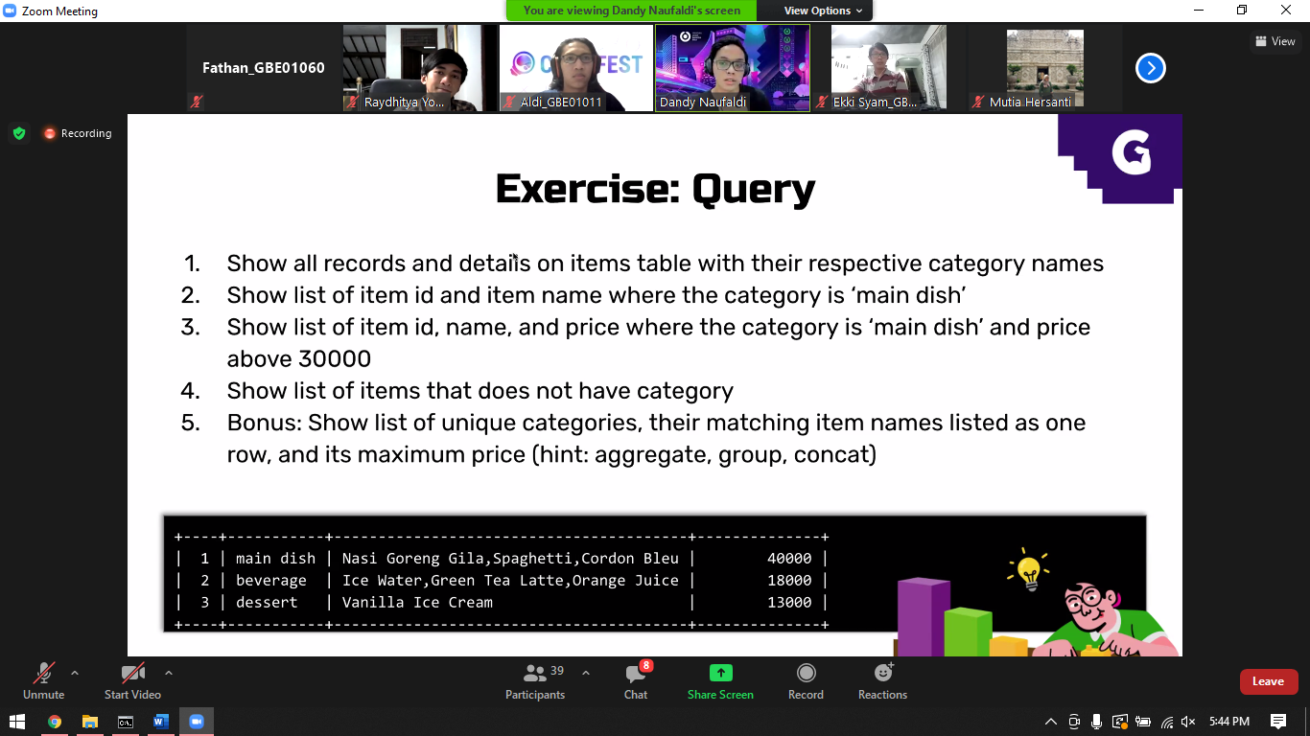

Select items.id, items.name, item_categories.categories_id

from items

left join item_categories on items.id = item_categories.items_id

nomor 4

Select items.id, items.name

from items

left join item_categories on items.id = item_categories.items_id

where categories_id is null;

nomor 3

Select items

.id, items.name, items.price, categories.name

from item_categories

left join items on items.id = item_categories.items_id

left join categories on categories.id = item_categories.categories_id

where categories.name = ‘main dish’;



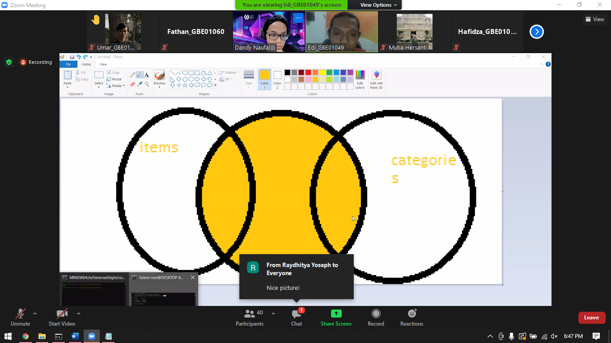

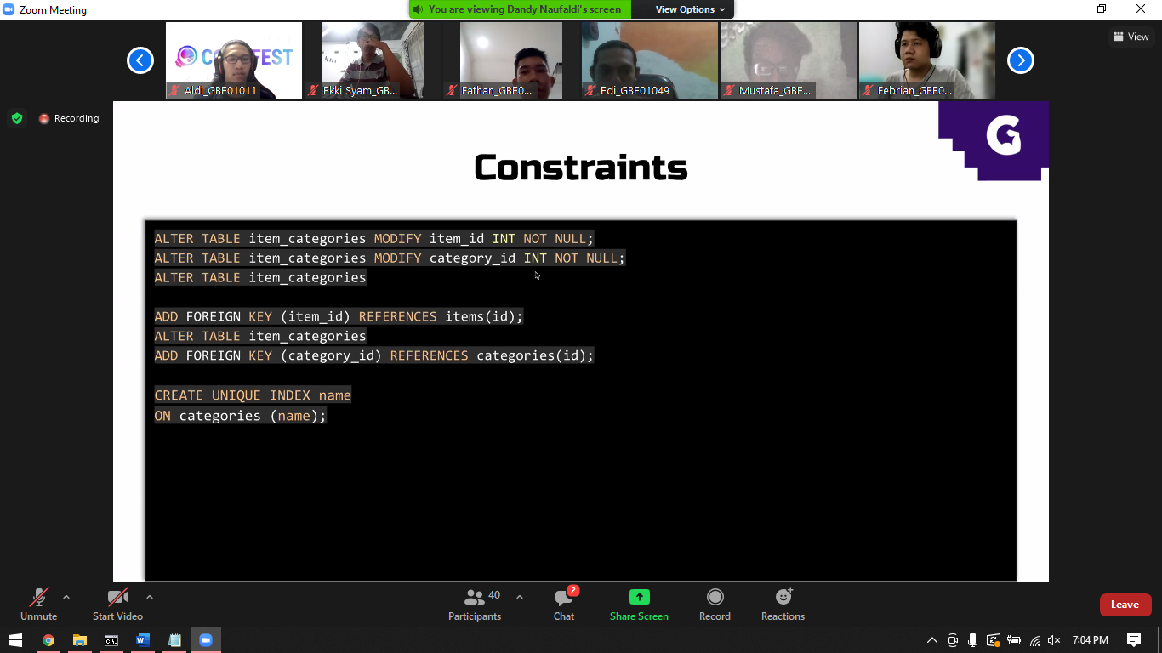

manual

index

missal di buku, cari halaman 1 by 1

kalo pake index, carinya lewat daftar isi. Faster right

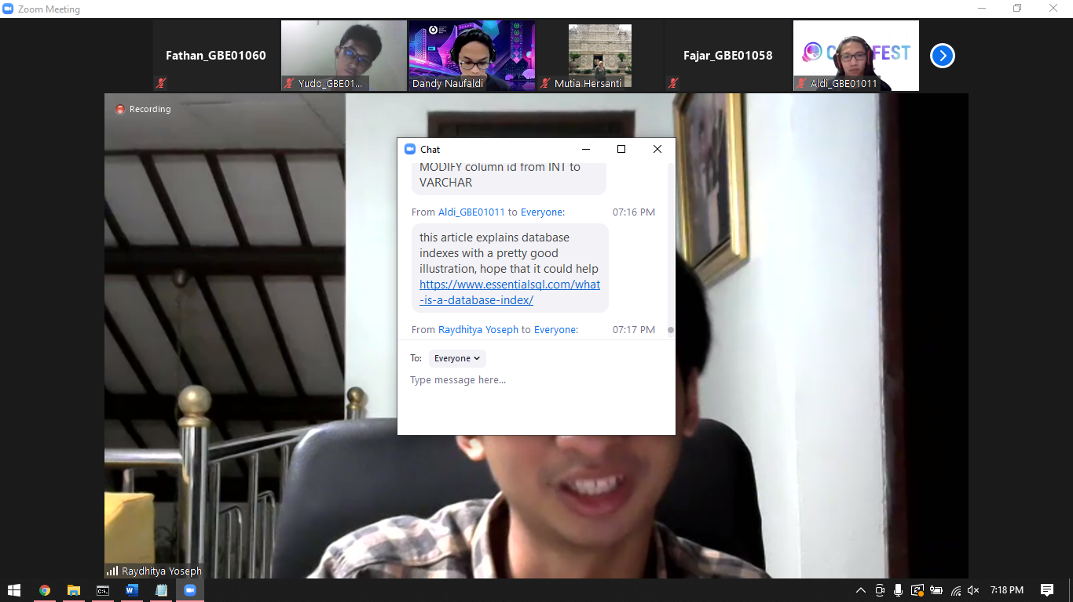

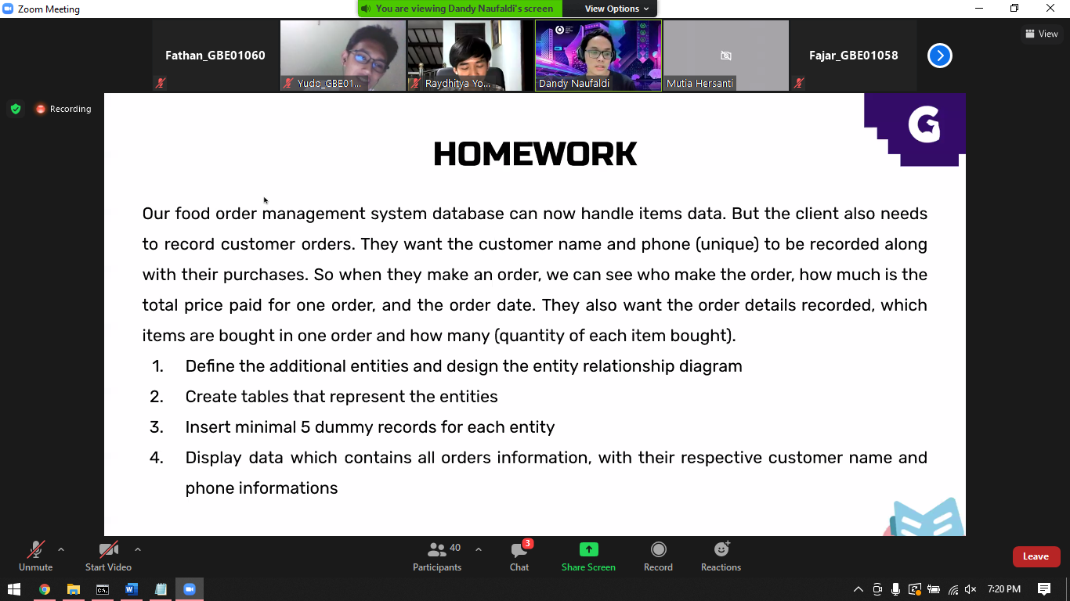

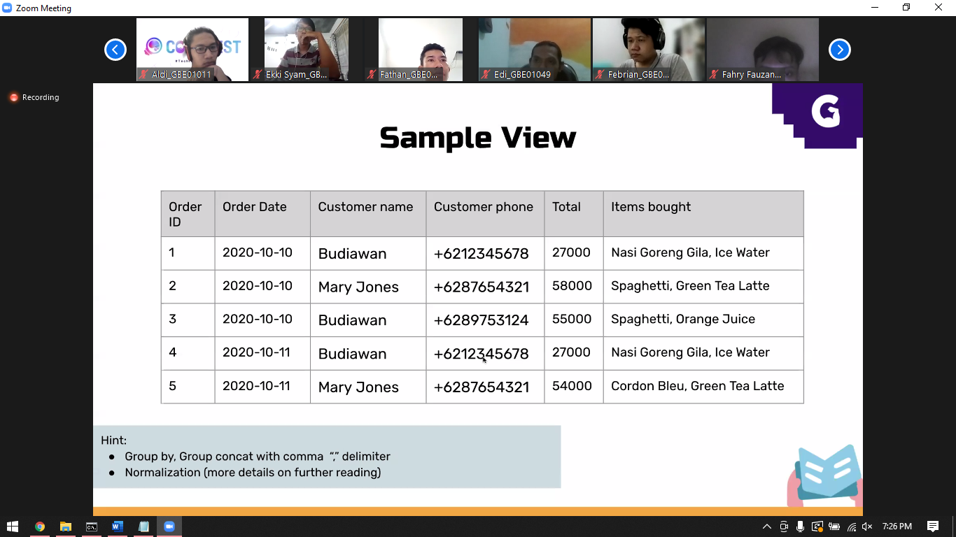

<https://www.oreilly.com/videos/introducing-sql-and/9781484238417/9781484238417-Taylor_Part04Segment01/>